Project Plan

Card Czar Android App

CMSC 495

Group 2 Final Project

Kenneth Mikkalson

Alton Hinton

Shawn Henson

Sarah Holley

Tara Lawson

Richard Wysong

**Table of Contents**

1 Overview 2

1.1 Project Summary 2

2 References 2

2.1 IEEE 2

3 Terms and Definitions 3

4 Project Organization 3

4.1 External interfaces 3

4.2 Internal Structure 4

4.3 Roles and Responsibilities 5

5 Managerial process plans 5

5.1 Work Plan 5

5.2 Risk management plan 5

6 Technical process plans 6

6.1 Process model 6

6.2 Methods, tools and techniques 6

7 Appendix A - 5.1.1 and 5.1.2 Diagrams 8

8 Appendix B – 5.1.3 Resource Allocation/Project Duration Calculations 0

# Overview

## Project Summary

### Scope

### The scope of the software development plan is the overall governing document in the development life cycle of the coffee maker system. The software development plan is written for program management personnel to assist in making informed decisions for the Card Czar Application system life cycle.

### Purpose

### The purpose of the software development plan is to identify all key aspects of controlling the overall development processes. The software development plan will describe the best practices that will be followed to complete the Card Czar Android Application.

### Assumptions and constraints

For this project it is assumed that the user will have access to a PC with an Android emulator or an Android phone using current Android OS software compatible with API 21. The user is expected to have a service contract or Wi-Fi access to access the Card Czar game. The system is constrained to the use of only the Android OS, no Apple compatible mobile application will be developed.

### Project Deliverables

The deliverable for this project is a mobile Android application. Card Czar is a spin-off of the popular party game Apples to Apples.

# References

## IEEE

### IEEE Std 1058-1998 IEEE Standard for Software Project Management Plans. IEEE Computer Society, 1998.

IEEE Software Engineering Standards Committee, “IEEE Std 830 1998, IEEE Recommended Practice for Software Requirements Specifications”, October 20IEEE Software Engineering

Standards Committee, “IEEE Std 1016 1998, IEEE Recommended Practice for Software Design Descriptions”, October 20

# Terms and Definitions

|  |  |
| --- | --- |
| **Term** | **Definition** |
| Testrail | External Testing Software site |
| GitHub | External Configuration Management site |
| LAMP | Acronym of the names of its original four open-source components: the Linux operating system, the Apache HTTP Server, the MySQL relational database management system (RDBMS), and the PHP programming language. |
|  |  |

# Project Organization

## External interfaces

### Testing Software

All software testing will be performed in a COTS testing cloud-based software solution. Testrail web hosting is provided by Gurock Software GmbH. Testing will be performed by the testing team.

### Software Configuration Management

All software configuration management will be handled in GitHub. GitHub is a Web-based Git repository hosting service, which offers all of the distributed revision control and source code management (SCM) functionality of Git. Java and PHP Code will be checked into GitHub

### LAMP Server

An external server that provides Apache, MySQL and PHP on a Linux server. Further detailed below in Methods and Tools.

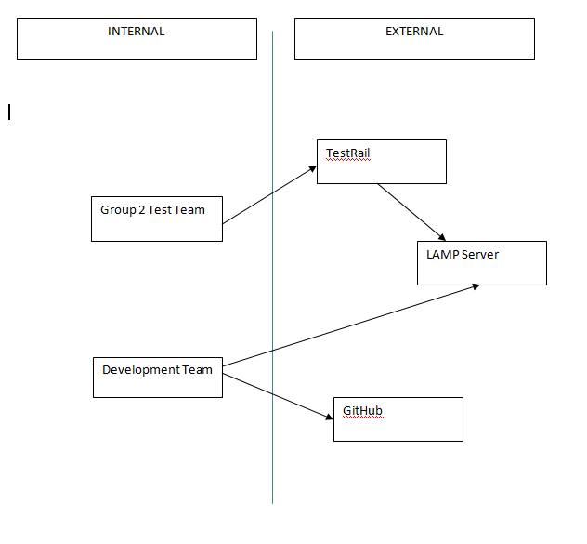

## Internal Structure

### Project Manager

### Software Development Lead

### Developer

### Documentation

### Test Lead/Security

### Configuration Management

### Test Team

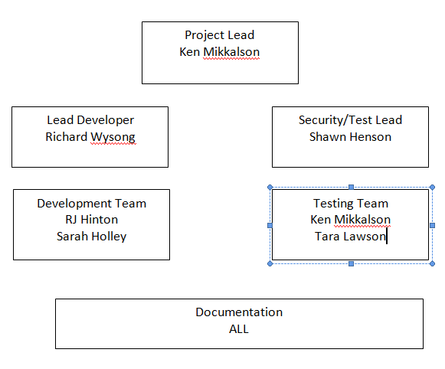

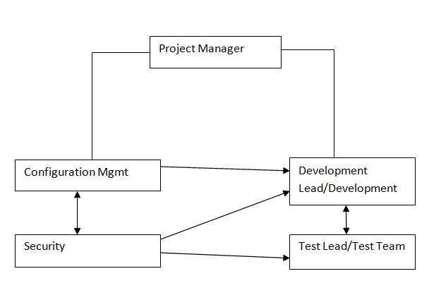

## Roles and Responsibilities

### Ken Mikkalson – Project lead, assist in all documentation, requirements definition, software testing

### Richard Wysong – Lead developer, coordinate software architecture, requirements definition, documentation.

### Shawn Henson – Lead testing, security posture, requirements definition, and documentation

### Sarah Holley - Software developer, requirements definition and documentation

### RJ Hinton – Configuration Management, software developer, requirements definition and documentation

### Tara Lawson – Testing, requirements definition, and documentation

# Managerial process plans

## Work Plan

### Work Activities - See Appendix A

## Risk management plan

|  |  |  |
| --- | --- | --- |
| Risk Number | Description | Probability |
| 1 | Loss of Key Team Member | Low |
| 2 | Android Development Unknowns | High |
| 3 | Security | Medium |

Risk 1 Mitigation – Loss of any team member would greatly increase workload share among remaining team members. Group two currently has five members on the team. Loss of any one member would be detrimental to completing the project and meeting project milestones on time. Loss of a team member would require re-evaluation of project goals and requirements. Functionality may have to be removed or modified based on new team composition.

Risk 2 Mitigation – Group two has no prior Android application development experience. High probability that hurdles will be encountered that will have to be worked through or worked around based on known work around.

Risk 3 Mitigation - Without Android experience and lack of tools to check for security issues, the application will be developed with best practice for internet application. The use of SSL for the web server will be employed as well as ensuring no phone, location or personal data is transmitted.

# Technical process plans

## Process model

Linear-sequential – Waterfall

## Methods, tools and techniques

### Android Software - Java will be used for Android based code

### LAMP Server Software – Web server, application software and database will be based on open source software.

OS - Linux

Web Server - Apache httpd Programming Language - PHP

Database - MySQL (MySQL

### Tools

Integrated Development Environment (IDE) – Android Studio is an integrated development environment (IDE) for developing on the Android platform. Application software development will be performed by the software development team

## Requirements

### Hardware

* The application shall be Android OS only
* Relational Database shall be utilized to hold player and game state data

### Software

* The application shall be API 21 compatible Android OS
* The application shall be written in Java
* The application shall use the following protocols

PHP - for use on LAMP Server

Apache - for use on LAMP Server

MYSQL - for use on LAMP Server

### Application Interface

* The application shall communicate via Wi-Fi for connectivity to LAMP server

### User Interface

* The players shall enter the game into a lobby until all users are ready to start
* Once entered the “Card Czar” (Dealer) shall be chosen at random.
* One phrase card shall be chosen at random per round
* Each player shall be able to choose only one card from their hand per round
* The dealer shall be able to choose the winning card, ending the round.
* The winner of the round shall receive one point
* The winner of the round shall be the dealer for the following round

## Use Case Diagrams

### Use Case 1

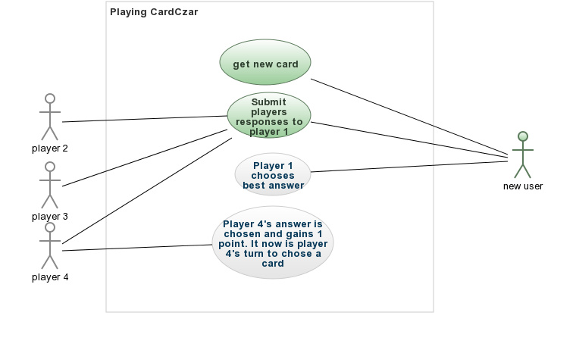

### Use Case 2

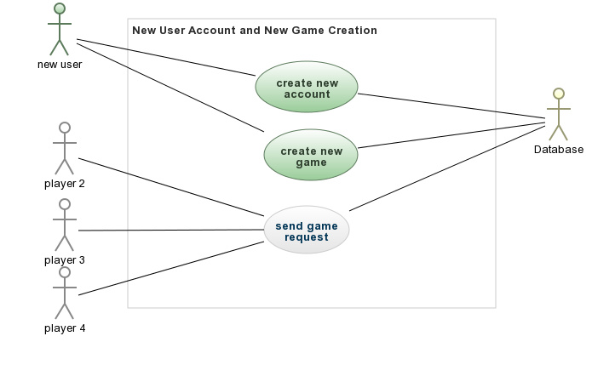

## Proposed App Layout

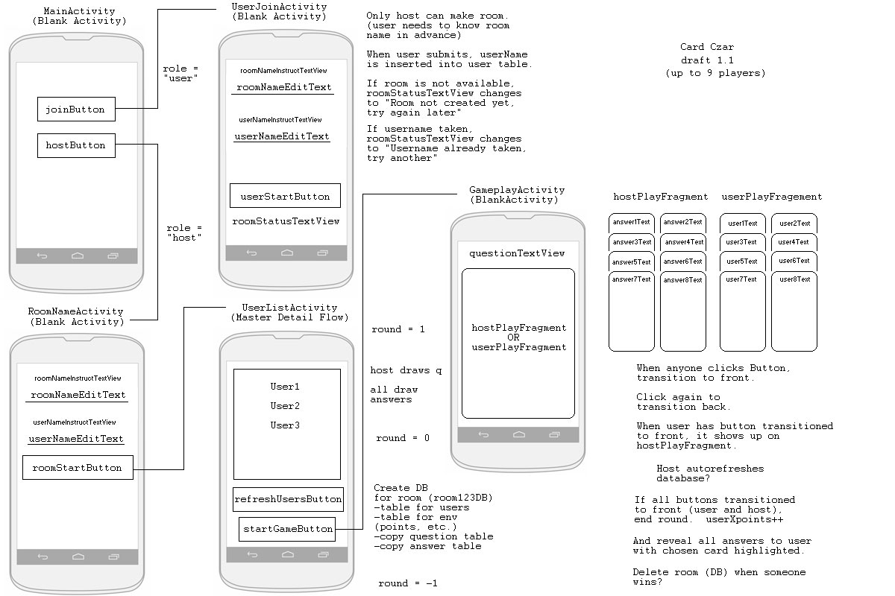

## Database Table

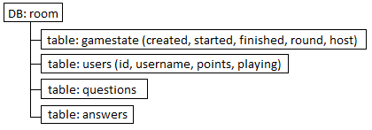

Appendix A - 5.1.1 Diagram

Work Activities 5.1.1

